Experiment No. : 3

Aim: To Develop Tic-tac-toe mobile game.

Objective : To learn about diffrent layouts available and using those create a tictactoe mobile game.

Theory: Types of Layouts:

The layouts most commonly used are:

Linear Layout
Relative Layout
However there are several other layouts such as:

Web View Layout
Frame Layout
List View Layout
Grid View Layout
Here we try to discuss these layouts in brief as these layouts are used extensively in any Android Project.

Linear Layout:

Linear Layout is a layout which aligns the widgets or elements in a linear (Straight) fashion. Linear Layout consists of two types of orientation:

Vertical Orientation,
Horizontal Orientation.
Vertical Orientation is shown above where the widgets such as Text View, Edit Text, and Button are aligned in a Vertical manner.
Relative Layout:
Relative Layout is a layout where the widgets (such as Text Views, Buttons, etc.) are represented with respect to previous widget or parent View. A Relative Layout example is shown in the figure below.
List View:
It is one of the very useful form of layouts. List view, as shown in figure below consists of an order of List items as shown below.

Code:
package com.example.tictactoe;

import androidx.appcompat.app.AppCompatActivity;

import android.os.Bundle;
import android.view.View;
import android.widget.GridLayout;
import android.widget.ImageView;
import android.widget.LinearLayout;
import android.widget.TextView;
import android.widget.Toast;

public class MainActivity extends AppCompatActivity {
// 0=yellow player and 1=red player
int activePlayer = 0;
boolean gameIsActive = true;

//2 means unplayed
int[] gameState = {2,2,2,2,2,2,2,2,2};

int[][] winningPositions ={{0,1,2},{3,4,5},{6,7,8},{0,3,6},{1,4,7},{2,5,8},{0,4,8},{2,4,6}};

public void dropIn(View view) {

ImageView counter = (ImageView) view;

int tappedCounter = Integer.parseInt(counter.getTag().toString());
if (gameState[tappedCounter] == 2 && gameIsActive) {
gameState[tappedCounter]=activePlayer;

counter.setTranslationY(-1000f);
if (activePlayer == 0) {
counter.setImageResource(R.drawable.yellow);
Toast.makeText(this, "Yellow played,Red's Turn", Toast.LENGTH_SHORT).show();
activePlayer = 1;
} else {
counter.setImageResource(R.drawable.red);
Toast.makeText(this, "Red Played,Yellow's turn", Toast.LENGTH_SHORT).show();
activePlayer = 0;
}
counter.animate().translationYBy(1000f).rotation(360).setDuration(300);

for (int [] winningPosition : winningPositions){

if (gameState[winningPosition[0]] == gameState[winningPosition[1]] &&
gameState[winningPosition[1]] == gameState[winningPosition[2]] &&
gameState[winningPosition[0]] != 2){

//someone has won!!

gameIsActive = false;

String winner = "Red";

if(gameState[winningPosition[0]]==0){
winner = "Yellow";
}

TextView winnerMessage = findViewById(R.id.winnerMessage);

winnerMessage.setText(winner + " Has won!!!");
LinearLayout layout = findViewById(R.id.playAgainLayout);

layout.setVisibility(view.VISIBLE);

}else
{
boolean gameIsOver = true;

for (int counterState : gameState){
if (counterState == 2) gameIsOver = false ;
}
if (gameIsOver){
TextView winnerMessage = findViewById(R.id.winnerMessage);

winnerMessage.setText(" It's a DRAW ");
LinearLayout layout = findViewById(R.id.playAgainLayout);

layout.setVisibility(view.VISIBLE);
}
}

}
}
}

public void playAgain(View view){

LinearLayout layout = findViewById(R.id.playAgainLayout);

layout.setVisibility(view.INVISIBLE);

activePlayer = 0;

gameIsActive = true;

for (int i=0; i < gameState.length ; i++ ){
gameState[i] = 2;
}

GridLayout gridLayout = findViewById(R.id.gridLayout);

for (int i=0 ; i< gridLayout.getChildCount() ; i++ ){
((ImageView) gridLayout.getChildAt(i)).setImageResource(0);
}

}

@Override
protected void onCreate(Bundle savedInstanceState) {
super.onCreate(savedInstanceState);
setContentView(R.layout.activity_main);
}

}

Output :
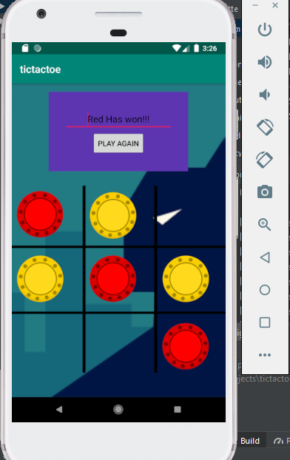

Conclusion:
Succesfully developed the Tic Tac Toe game in Android studio.

